File Compression Using Huffman Coding is a Java-based project that compresses text data by assigning shorter binary codes to frequently used characters. It uses Data Structures such as HashMap, Priority Queue, and Binary Tree to build a Huffman Tree and perform compression. The system can also decompress the data back to its original form without any loss of information.

University Name: UCP
Department Name: SE

Course Name: DSA
Semester: 4th Semester
Section: D8
Submission Date: 14-6-2026
INSTRUCTOR: ABDUL REHMAN
LAIBA LIAQAT
L1F24BSSE0374

FILE COMPRESSION USING HUFFMAN CODING
DSA PROJECT

Introduction
Data compression is an important technique used in modern computing systems to reduce file size and improve storage efficiency. Large files require more storage space and increase transmission time over networks. Therefore, efficient compression techniques are necessary to minimize storage requirements while preserving data integrity.
This project implements File Compression Using Huffman Coding, which is a lossless data compression algorithm. Huffman Coding assigns shorter binary codes to frequently occurring characters and longer binary codes to less frequent characters. This approach reduces the total number of bits required to represent the original data.
The system first analyzes the frequency of each character in the input text. Based on these frequencies, a Huffman Tree is constructed using a Priority Queue (Min Heap). Binary codes are then generated by traversing the tree. The original text is compressed into a binary sequence and can later be decompressed back to its original form without any loss of information.
This project was selected because it demonstrates practical applications of Data Structures and Algorithms such as Trees, HashMaps, Priority Queues, and Greedy Algorithms. It also provides real-world relevance since compression techniques are widely used in ZIP files, multimedia formats, and communication systems.

Problem Statement
The objective of this project is to design and implement a Java-based File Compression System using Huffman Coding. The system should efficiently compress text by reducing the number of bits required for storage and transmission while ensuring that the original text can be perfectly reconstructed through decompression.

Data Structures Used

1. HashMap
Purpose:
- Store character frequencies.
- Store generated Huffman codes.
Usage:
- Character → Frequency mapping.
- Character → Binary Code mapping.

2. Priority Queue (Min Heap)
Purpose:
- Efficiently retrieve nodes with minimum frequency.
Usage:
- Building Huffman Tree.

3. Binary Tree (Huffman Tree)
Purpose:
- Generate optimal Huffman Codes.
Usage:
- Left Edge = 0
- Right Edge = 1

Algorithms Implemented:

Huffman Coding Algorithm
Purpose:
To perform lossless compression by assigning variable-length binary codes based on character frequency.
Steps:
- Calculate frequency of characters.
- Insert nodes into Priority Queue.
- Extract two minimum frequency nodes.
- Create parent node.
- Repeat until tree is formed.
- Generate binary codes.
- Compress input text.
- Decompress binary data.
Algorithm Type:
Greedy Algorithm
Time Complexity:
O(n log n)
Space Complexity:
O(n)

Core Functionalities
- Character Frequency Calculation
- Huffman Tree Construction
- Huffman Code Generation
- Text Compression
- Text Decompression
- Compression Ratio Calculation
- Display Compression Statistics

System Screenshots:

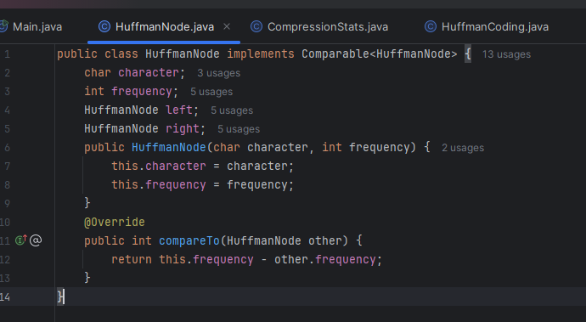

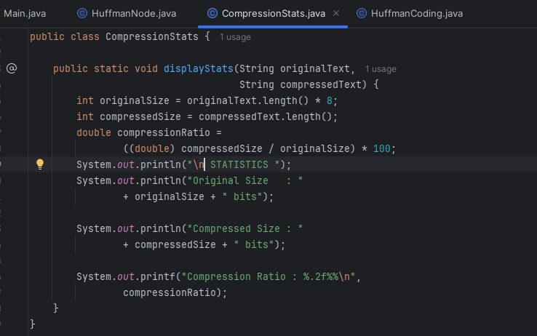
import java.util.*;
public class HuffmanCoding {
private HashMap<Character, String> huffmanCodes;
private HuffmanNode root;
public HuffmanCoding() {
huffmanCodes = new HashMap<>();
}
public void buildTree(String text) {
HashMap<Character, Integer> frequencyMap =
new HashMap<>();
for (char c : text.toCharArray()) {
frequencyMap.put(c,
frequencyMap.getOrDefault(c, 0) + 1);
}
PriorityQueue<HuffmanNode> minHeap =
new PriorityQueue<>();
for (Map.Entry<Character, Integer> entry :
frequencyMap.entrySet()) {
minHeap.add(new HuffmanNode(
entry.getKey(),
entry.getValue()));
}
while (minHeap.size() > 1) {
HuffmanNode left = minHeap.poll();
HuffmanNode right = minHeap.poll();
HuffmanNode parent =
new HuffmanNode(‘\0’,
left.frequency + right.frequency);
parent.left = left;
parent.right = right;
minHeap.add(parent);
}
root = minHeap.poll();
generateCodes(root, “”);
}
private void generateCodes(HuffmanNode node,
String code) {
if (node == null)
return;
if (node.left == null &&
node.right == null) {
huffmanCodes.put(node.character,
code.length() > 0 ? code : “0”);
}
generateCodes(node.left, code + “0”);
generateCodes(node.right, code + “1”);
}
public String compress(String text) {
StringBuilder compressed =
new StringBuilder();
for (char c : text.toCharArray()) {
compressed.append(huffmanCodes.get©);
}
return compressed.toString();
}
public String decompress(String compressedText) {
StringBuilder result =
new StringBuilder();
HuffmanNode current = root;
for (char bit :
compressedText.toCharArray()) {
if (bit == ‘0’)
current = current.left;
else
current = current.right;
if (current.left == null &&
current.right == null) {
result.append(current.character);
current = root;
}
}
return result.toString();
}
public void displayCodes() {
System.out.println(“\Nhuffman CODES”);
for (Map.Entry<Character, String> entry :
huffmanCodes.entrySet()) {
System.out.println(entry.getKey()
+ “ : “
+ entry.getValue());
}
}
}

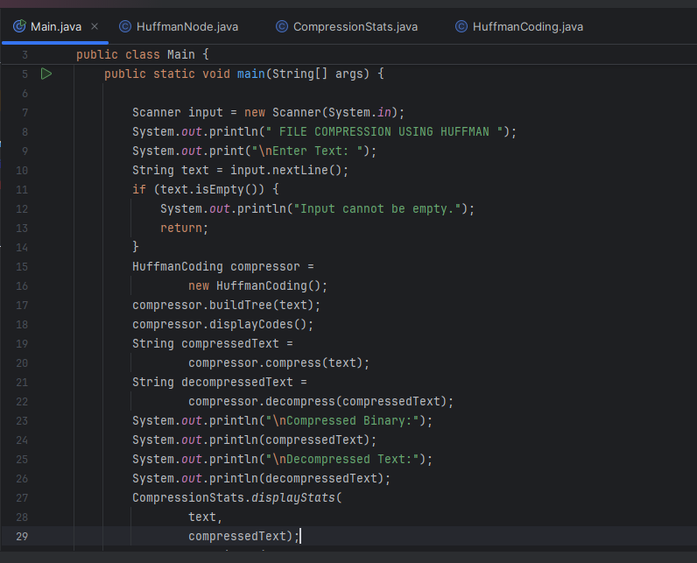

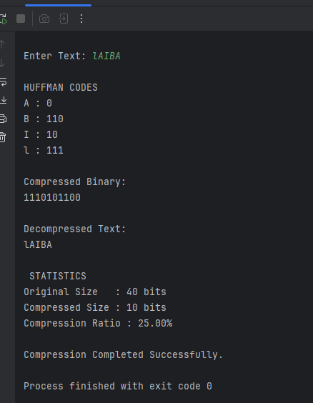

How to Run the Project:
Requirements:
- Java JDK 21 (or above)
- IntelliJ IDEA / NetBeans / Eclipse
Steps:
- Install Java JDK.
- Open IDE.
- Create Java Project.
- Copy source code into Main.java.
- Compile project.
- Run Main.java.
- Enter text for compression.
- View compressed and decompressed results.

GitHub Repository Link:
GitHub Repository:
https://github.com/laiba810/FILE-COMPRESSION-PROBLEMR
epository Contains:
- Complete Source Code
- README.md
- Project Documentation
- Screenshots
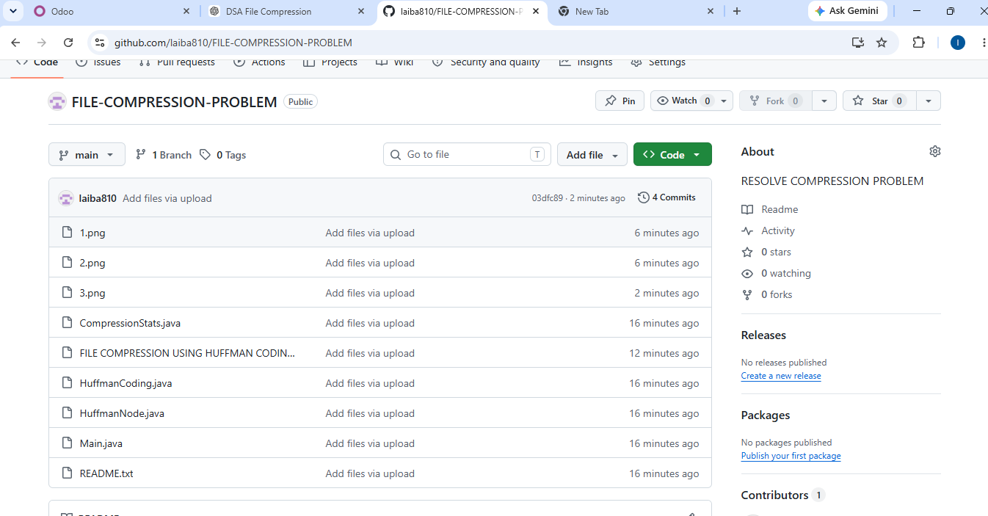

Conclusion:
This project provided practical experience in implementing Data Structures and Algorithms using Java. Through the development of Huffman Coding, concepts such as HashMaps, Priority Queues, Binary Trees, and Greedy Algorithms were applied to solve a real-world problem.
The project improved understanding of algorithm design, problem solving, and object-oriented programming. It also demonstrated how efficient data structures can significantly improve system performance and storage efficiency.

